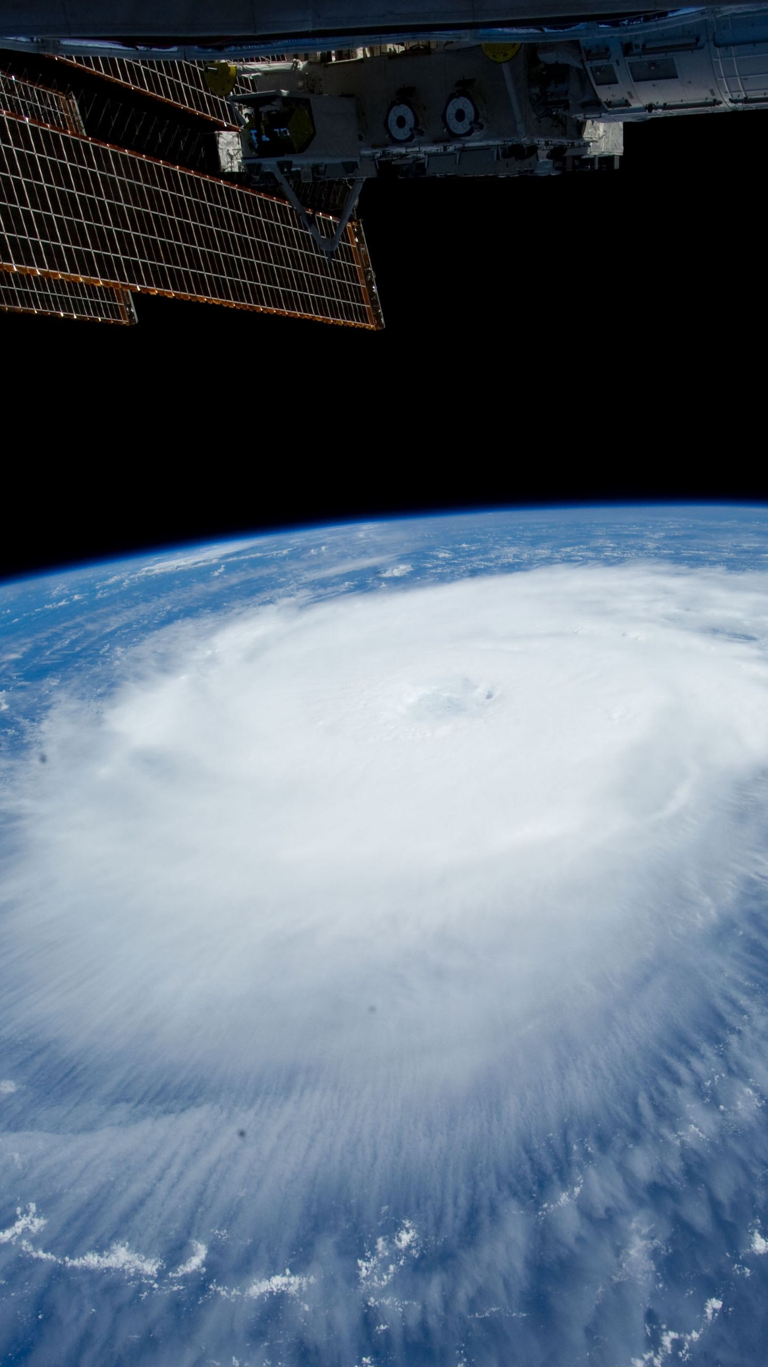
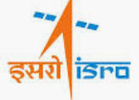

UN Health Innovation exchange.
Authored by: Biju Jacob, Director UNHIEX
Kiran Rao, Ex director ISRO
Research by: Vivek Nair

August 2020

Global Partnership to Harness and Scale Space-Tech for Health Innovations.

2020

How can we take harness Space-tech for health?

Since the beginning of the space age, there have been those who criticized space exploration for not benefitting the common man in any way. Arguably, in the beginning, this may have been true. Afterall, the first satellite was launched with an aim to intimidate an opponent, not with the goal of exploring space.

Today, the scenario has changed completely. Even though the goal is space exploration, the people living here on earth also benefit along every step of the way. For every telescope or probe launched there are many others that make telecommunication, GPS, and remote sensing possible. The fact is that we are now in an era where the tech that makes life in space possible can be used to make life here on earth more comfortable.

Space technology has slowly, but steadily built up to a point where it can benefit us. We can think of the first space missions as scouting missions. We were exploring new territory, unsure of what it presents in the form of resources. Later, as we started to send up stations like the Mir and Skylab, we were reluctant settlers, still not completely sure of the place’s offerings, but firmly believing that it would be worth it. Fast forward 20 years and we have created the International Space Station.

The ISS is the pinnacle of human cooperation and ingenuity. It is humanity’s outpost among the stars. This engineering marvel is meant to be a testing ground for missions to take humans further away from Earth than we have ever been. But it is, in fact, a laboratory. Finding out the effects of micro gravity on the human body, measuring cosmic radiation and trying to detect dark matter is only a fraction of what is done on the ISS. A majority of the experiments done directly make life better for the common man.
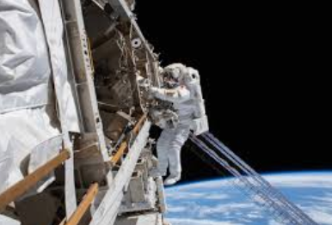

Telemedicine.
Telemedicine has received a huge boom in recent times. People can now meet with doctors and discuss their symptoms online. This is particularly useful in rural regions where the people may not have access to doctors. Now with Covid-19 spreading, telemedicine has been thrust into the spotlight as a safe method for doctors to communicate with their patients without having to put themselves at risk.

Many countries are now investing in satellites to facilitate faster communication. SpaceX has already started building a network of over 150 satellites that will make telecommunication faster and more wide-spread. Startups like Jeff Bezos’ Blue Origin are now following suit.

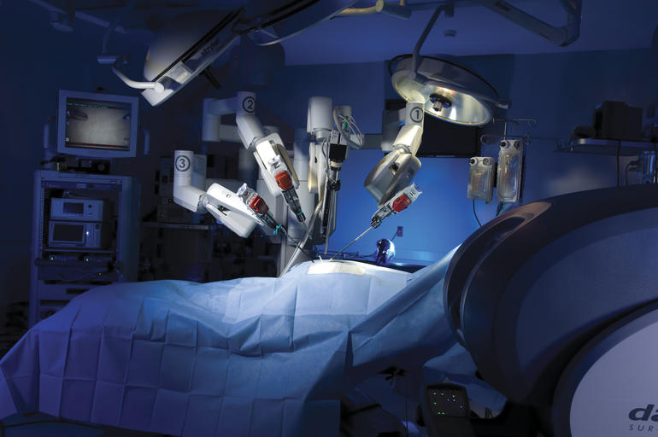
Robotics in Surgery.
The CanadArm2 on the ISS is a masterpiece of engineering. Many of the robotic arms used in factories and assembly plants are direct descendants of the CanadArm. Today, these arms are advanced enough that they are used in prosthetics and even for surgeries. These arms allow doctors to remotely perform surgeries from anywhere in the world. Research on ISS has allowed for innovations in surgical performance through the world’s first robotic technology capable of performing surgery inside MRI machines. This technology is making difficult brain tumor surgeries easier and impossible surgeries possible.

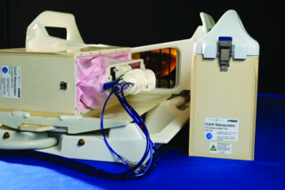
Breast Cancer.
Technology derived from the highly capable robots designed for the ISS may soon increase access to life-saving surgical techniques to fight breast cancer. Researchers created IGAR from a long line of Canadian heavy lifters and maintenance performers for the space shuttle and space station Canadarm, Canadarm2 and Dextre.

Medical technology stemming from space station robotics will enter clinical trials for use in the early diagnosis and treatment of breast cancer by providing increased access, precision and dexterity resulting in highly accurate and minimally invasive procedures.

Asthma Detection.
The astronauts breathe into a specially developed instrument that measures nitric oxide levels. The purpose of taking reduced measurements in an airlock––normally used to exit a spacecraft for spacewalks, and is set at a 30% reduced pressure–– is to simulate conditions in future habitats on Mars, and is equivalent to being at 3000 m (9843 ft) altitude on Earth. The device that measures the nitric oxide is lightweight, easy to use and accurate. The same instrument is currently used in clinics and hospitals, helping asthmatics and offering a quick and cheap way to diagnose lung problems.

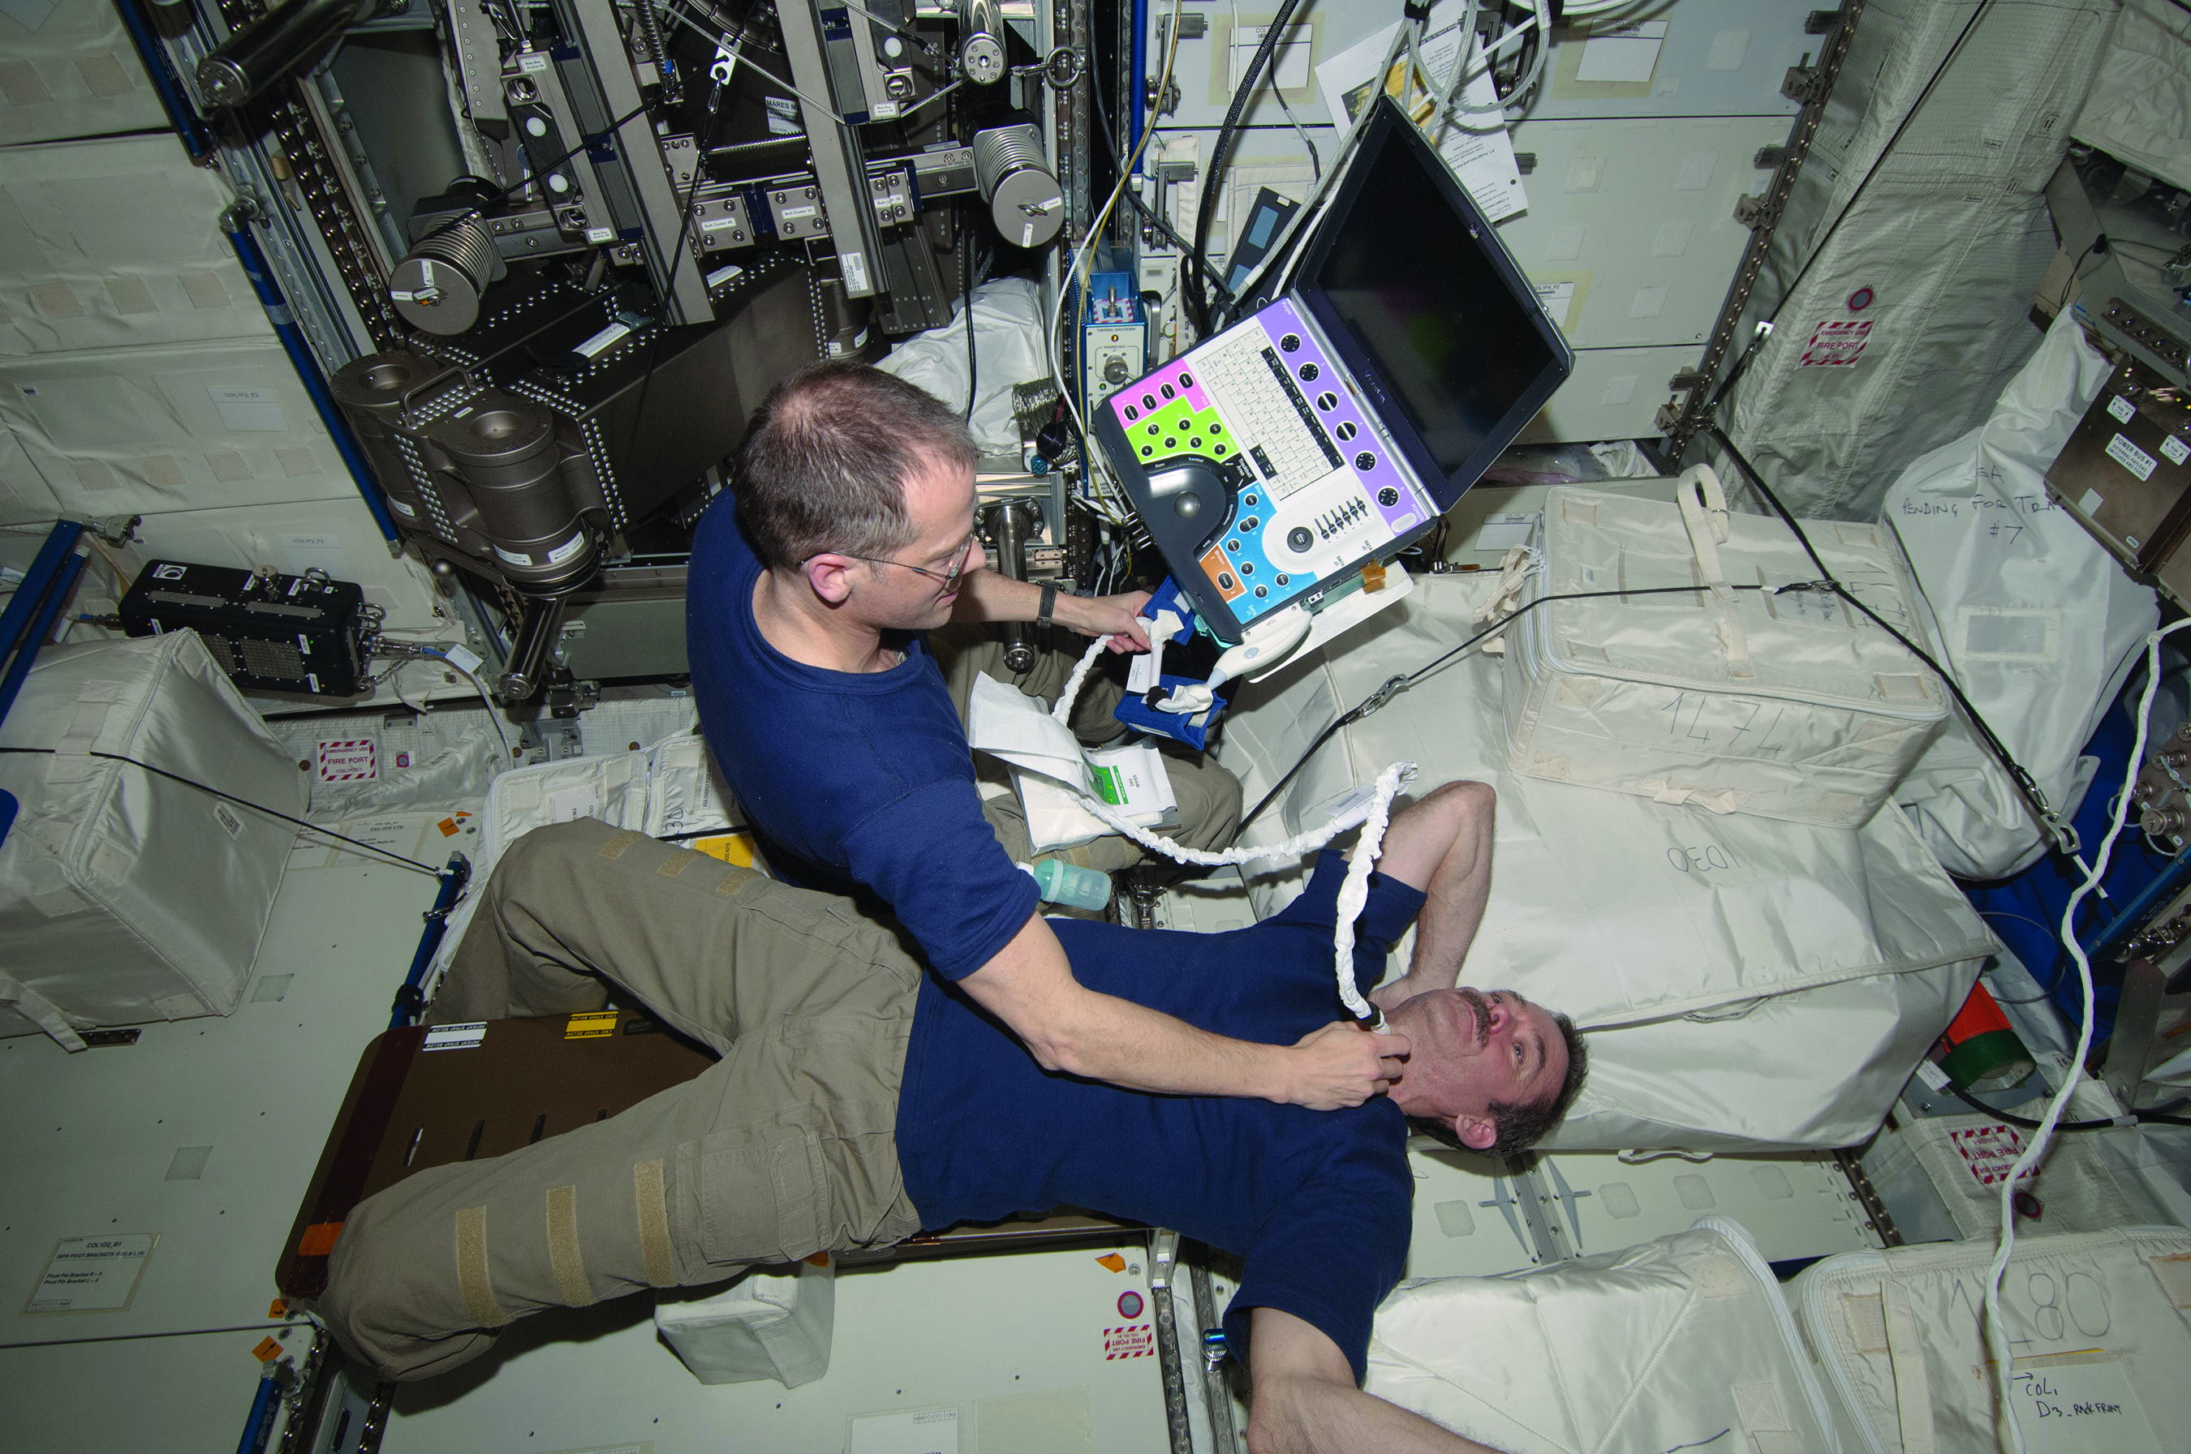

Ultrasound
Ultrasound imaging is among the fastest, safest and most universal diagnostic methods ever invented. It provides much of the information that can be obtained by expensive technologies, such as X-ray, computed tomography, or magnetic resonance imagery, and it is the only method to produce a real-time or live image that can be interpreted and/or transmitted at the same time. In the right hands, ultrasound instantly answers many clinical questions, shortening the assessment time and improving outcome. The key concept developed by the NASA team is the methodology for "Remote Expert Guidance" of ultrasound examinations, which links a remote expert with the on-site operator in a virtual common working environment. The ultrasound machine video output is transmitted to the remote expert via a satellite or Internet connection, and the operator is guided to obtain the ultrasound images via voice commands. This technique has dramatically reduced training requirements (often down to minutes) while preserving the quality of the ultrasound examinations. Such a device can be used in rural areas as it is portable. The images can be transmitted to the district or nodal health centers where doctors can analyze the reading s.

Wound healing.
A type of cold plasma could potentially be used for disinfecting wounds, helping them heal faster, and even to fight cancer. Complex plasma research has been taking place onboard the ISS since 2001. This research has improved our fundamental knowledge and provided tremendous insights in complex plasma research and how we can control complex plasmas (i.e., plasmas mixed with fine particles). The weightless environment is ideal for this area of research by allowing astronauts to produce macroscopic analogues of atomic structure in gases and liquids and observe phase transitions such as melting or freezing. Cold plasmas have the properties needed to safely and efficiently inactivate fungi, viruses, spores and odor molecules. In more than 3,500 examples in several clinical trials, physicians found plasmas can disinfect chronic wounds and help wounds heal faster.
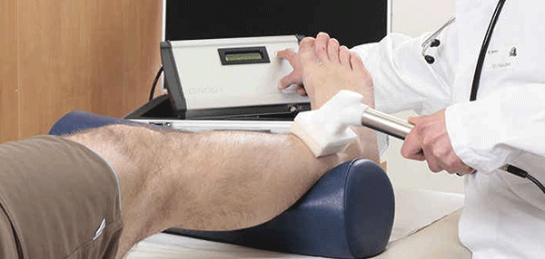
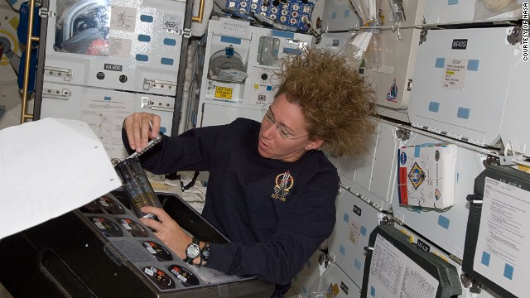
Vaccine development.
The space environment has been shown to induce key changes in microbial cells that are directly relevant to infectious disease, including alterations of microbial growth rates, antibiotic resistance, microbial invasion of host tissue, organism virulence (the relative ability of a microbe to cause disease), and genetic changes within the microbe (Wilson et al., 2007, 2008). The targets identified from each of these microgravity-induced alterations represent an opportunity to develop new and improved therapeutics, including vaccines, as well as biological and pharmaceutical agents aimed specifically at eradicating the pathogen.

Covid-19, Malaria Tracking and tracing.
Geospatial data is becoming an important tool for infectious disease modeling. In the future, satellites could be used to predict where the COVID-19 virus is likely to emerge. Satellite data has previously been used to successfully predict outbreaks of cholera and a team of researchers from the University of Maryland, College Park are currently working on a predictive model for the virus that causes COVID-19. Satellites can also be used to measure the effects COVID-19 is having on different regions and to detect communities that could be vulnerable to infection in unmapped areas by automatically identifying buildings and roads. Earth observation data can give insights into the environmental changes currently taking place due to COVID-19. Social distancing has led to a huge decrease in road traffic and as a result there are lower levels of pollutants such as nitrogen dioxide in the air. Satellites can also be a useful tool in measuring the economic impact that COVID-19 is having on a country. By tracking the movement of goods in ports, satellites can give an insight into the economic impact of COVID-19 as well as the pace of recovery.

Future Applications of space-tech to solve crises
Many of the systems designed for use in space can be adapted for use on Earth. The main hurdle for this is cost. These systems are optimized for space where the scale is much smaller. However, since this technology already exists, ways to make these systems more efficient and cost effective could most probably be created in the near future.

Water reclamation systems.
Space has nothing. It provides nothing in the way of resources or utilities. Everything that makes living in space possible must be sent up from Earth. We have slowly been developing technologies that make life in space self-sufficient. For example, until 2010, water used to arrive at the ISS in duffel bags. Now, there is a purification system that allows astronauts to reclaim more than 4800 liters. The water requirement for an average human is about 4 liters per day. Therefore, the same water reclaimed from sweat and urine could last for years. The space station however is a closed system, and results would be very different on Earth where it is not possible to preserve all water. But this tech shows huge promise and with some refining, could sustain populations in arid regions for a long time.

Agriculture to deal with Malnutrition.
On the ISS, plants are being grown in small numbers. While this is not enough for sustainability, it gives us time to monitor each plant individually and possibly, provide us with an optimal method of growing each type of crop. This could significantly increase yield.

The main players.
The US’s National Aeronautics and Space Administration (NASA), the Russian Federal Space Agency, the Japan Aerospace Exploration Agency, the French Centre National d’Etudes Spatiales, and the Canadian Aeronautics and Space Institute along with a number of UN agencies are some of the main entities contributing to global health through space research. However, there is little interaction with the startup eco-system

The current issues with technology transfer
Most of the companies working on the application of space technology in health are large organisations like NASA, ESA and Roscosmos. But these agencies are largely focused on their missions. Many of these experiments have been under testing for years now. This is partly due to the fact that these experiments are usually the victims of budget cuts. Tech- transfer gets put on the back-burner in favor of more glamorous projects.
The current eco-systems have not been able to transfer space technologies to the startup eco-system efficiently. Involving startups for technology transfer is a proven model and there is a need for a collaboration to bridge the gap between high-end research end space organizations and health startups . This will ensure at space research does not happen only in ivory towers.

Need to cross-industry collaboration.
UNHIEX has successfully fostered the collaboration with the international solar alliance and the Health startup eco-system.. By setting up a similar ecosystem for health-related applications with UNFIEX and ISRO, could boost testing speeds and make these life saving technologies mainstream years earlier. By having dedicated startups to focus on each of these projects individually. We could do them much faster. There are already many smaller companies that produce parts for boosters and satellites

Proposed next steps.

- Portal for information sharing on Space-tech:
We need to set up a database of all these experiments that have been carried out irrespective of whether they were successful or not. This database can be on the lines of the Medical Research Corp (MRC) which maintains a all the unsuccessful drug research details. This portal can be accessed by anyone anywhere. This will enable smaller startups to understand what went wrong the first time and potentially find solutions around these problems. Through this we can establish a large network of people that transcends international borders and get the brightest minds of the world to work on this collectively.

- “Space-tech for Health” Innovation Challenge
Organizations like UNHIE, ISRO, BIRAC etc. can come together to organize a technology innovation challenge for entrepreneurs to come up with relevant technologies that can be adapted to health.

- Setup incubation center
Setup an incubation center to focus on technology transfer from space research organization to health startups. The startups can also benefit hugely from the culture, processes and the management practices used by successful space agencies like ISRO and NASA, where innovation and scaling is key to survival and part of their DNA .

References
https://electronichealthreporter.com/can-healthcare-learn-aerospace-airlines-process-improvement-technology/, https://www.who.int/bulletin/volumes/96/1/17-206565/en/,
https://www.ncbi.nlm.nih.gov/pmc/articles/PMC6041558/,
https://tech.newstatesman.com/guest-opinion/space-innovations-healthcare,
https://www.isro.gov.in/applications/tele-medicine,
https://www.nasa.gov/mission_pages/station/research/benefits/human_health_benefits .
https://www.prnewswire.com/news-releases/satellites--covid-19-an-emerging-tool-for-virus-movement-predicitons-and-environmental--economical-monitoring

